Cloud Challenge 01
Step 1: Launch EC2
Choose:
Amazon Linux 2
t2.micro (Free Tier) 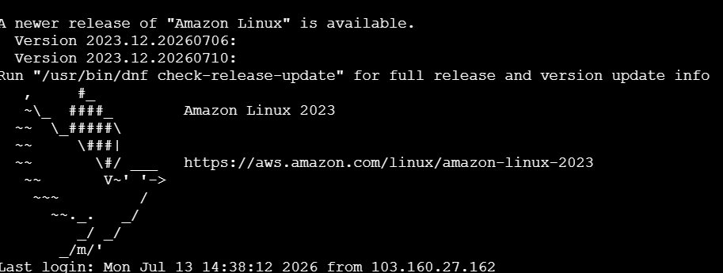
Allow Security Group Ports
PORT | PURPOSE
22 | SSH
8080 | Jenkins
81 | Inginx
82 | Apache
8082 | Tomcat

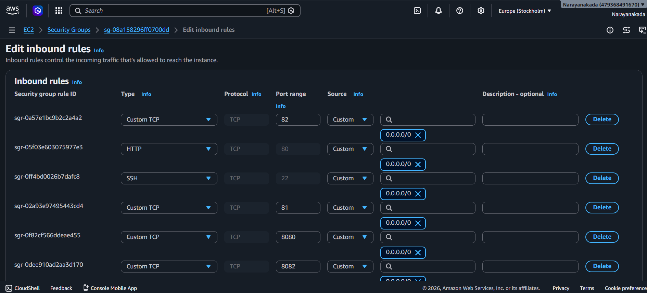
Connect
ssh -i key.pem ec2-user@<PUBLIC-IP>
ssh -i "linux-testing.pem" ec2-user@ec2-13-51-156-144.eu-north-1.compute.amazonaws.com
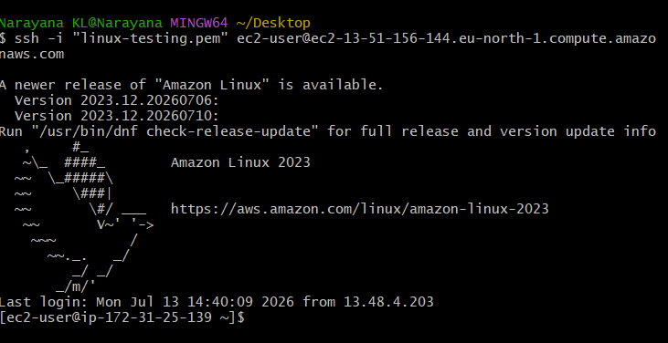
Step 2: Update Server
sudo yum update -y
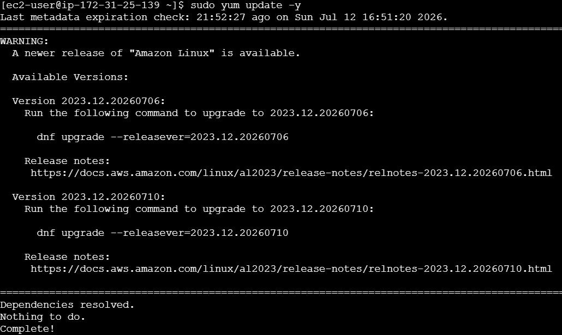

Step 3: Install Java
sudo amazon-linux-extras enable corretto21
sudo yum install java-21-amazon-corretto -y
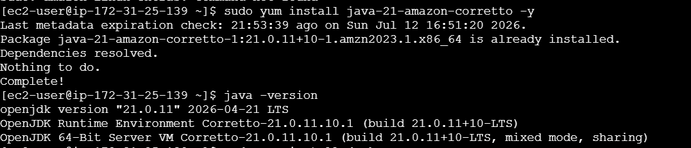
java -version
Step 4: Install Docker
sudo yum install docker -y
sudo systemctl enable docker
sudo systemctl start docker
sudo systemctl status docker
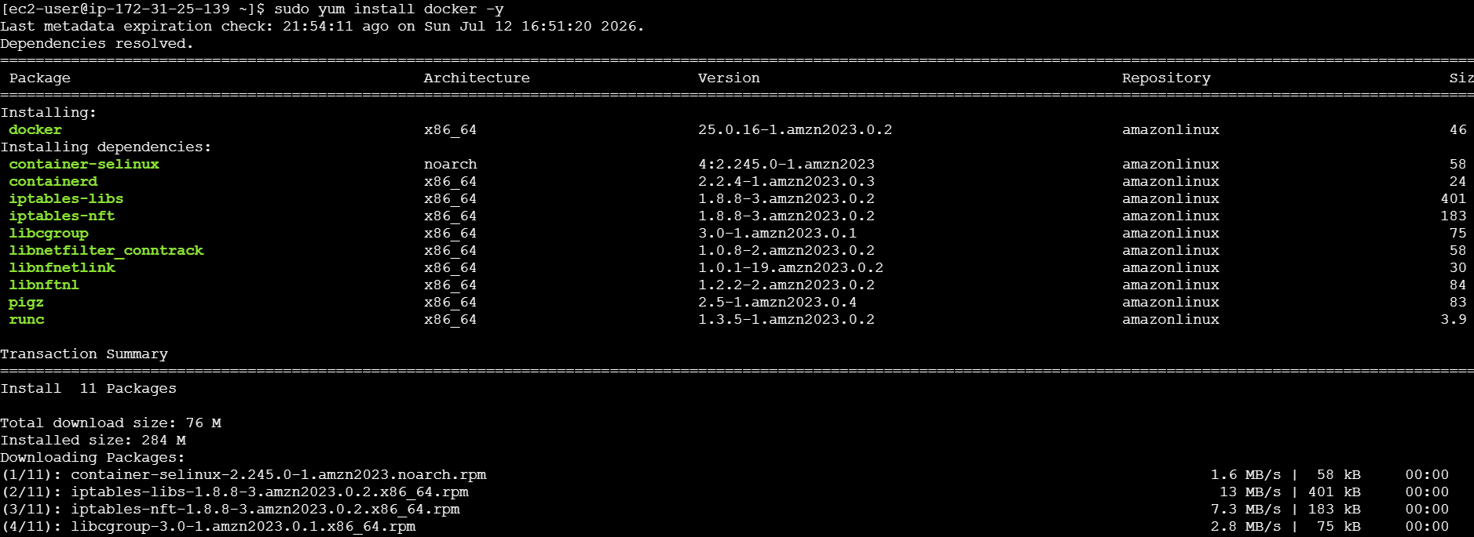
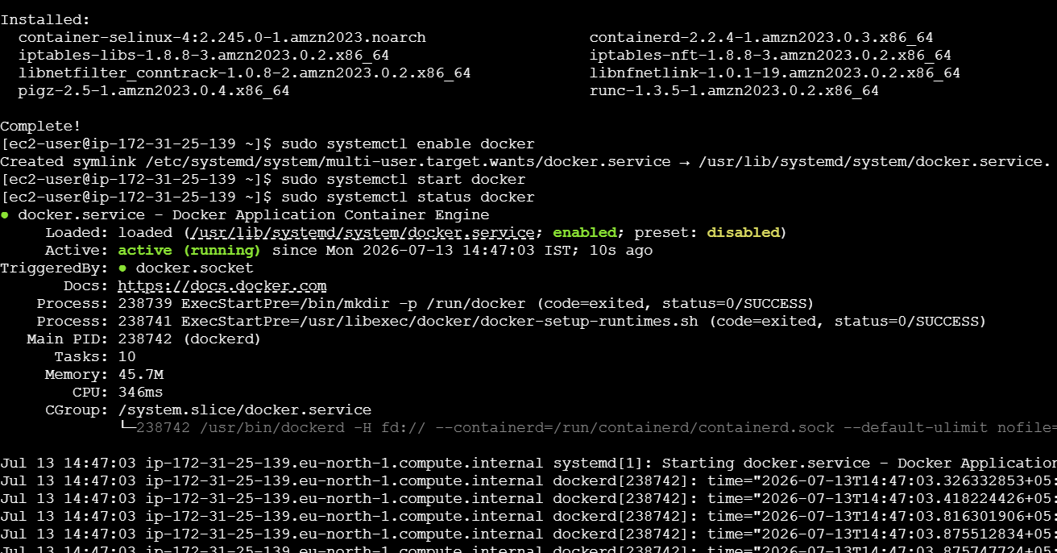
Add ec2-user to Docker group
sudo usermod -aG docker ec2-user
newgrp docker
Verify
docker –version
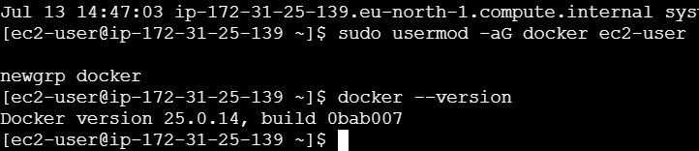

Step 5: Install Jenkins
Add Jenkins repository
sudo wget -O /etc/yum.repos.d/jenkins.repo \
https://pkg.jenkins.io/redhat-stable/jenkins.repo

sudo rpm --import https://pkg.jenkins.io/redhat-stable/jenkins.io-2023.key
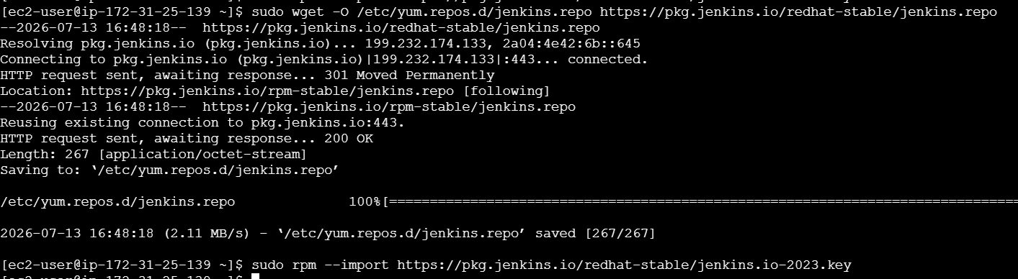
Install
sudo yum install jenkins -y
Start
sudo systemctl enable jenkins

sudo systemctl start jenkins

sudo systemctl status jenkins
Verify
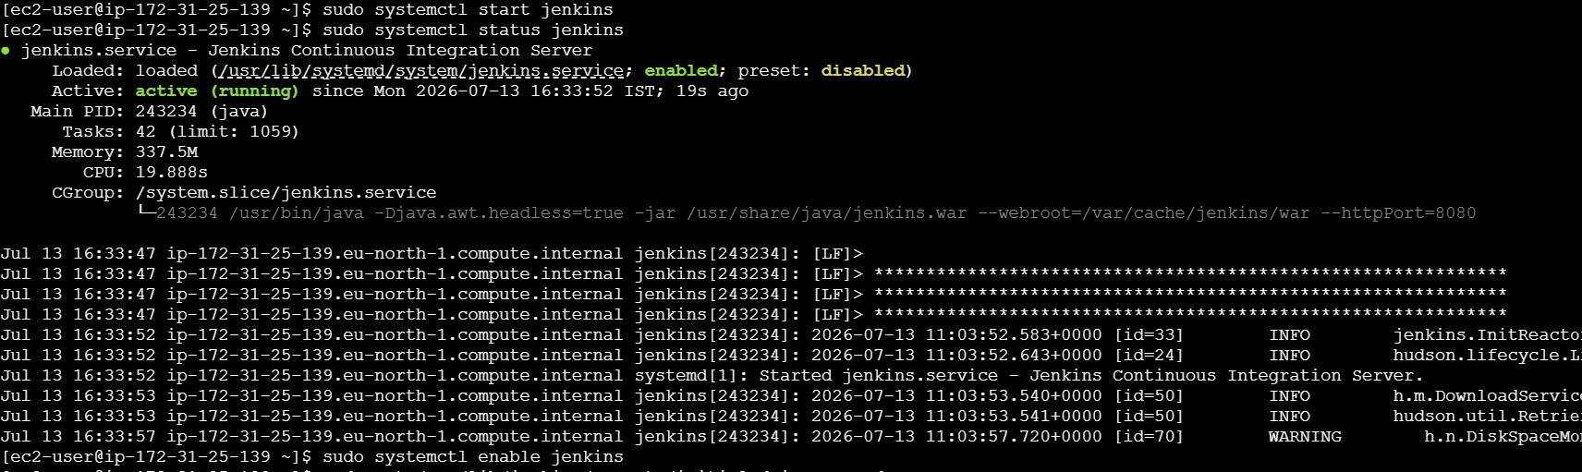
curl localhost:8080
Initial Password
sudo cat /var/lib/jenkins/secrets/initialAdminPassword
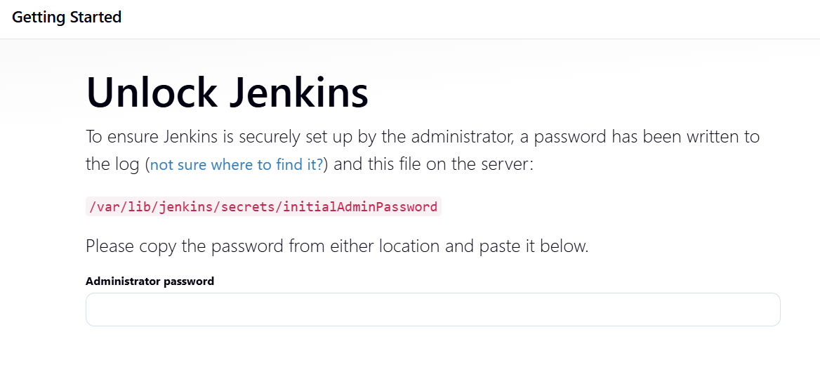
http://13.51.156.144:8080/

Step 6: Install Apache
sudo yum install httpd -y
Change Port
sudo vi /etc/httpd/conf/httpd.conf
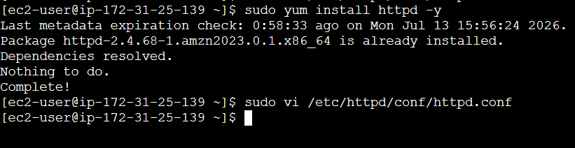
Find
Listen 80
Replace with
Listen 82
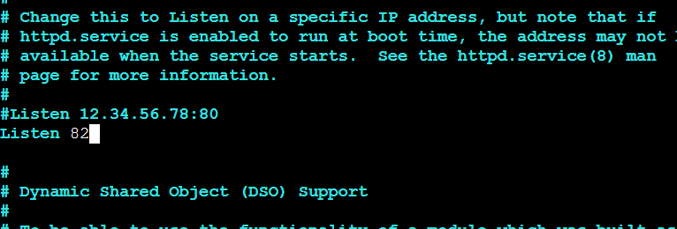
Create Sample Page
echo "<h1>Apache Running on Port 82</h1>" | sudo tee /var/www/html/index.html
Start Apache
sudo systemctl enable httpd

sudo systemctl restart httpd
Verify
curl localhost:82
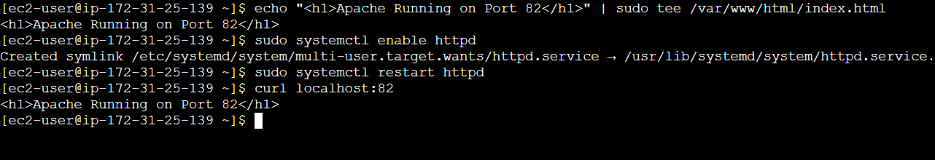
http://13.51.156.144:82/

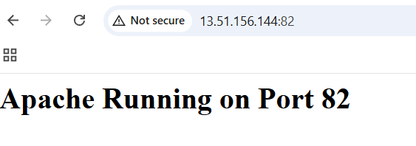

Step 7: Install Nginx
Amazon Linux 2:
sudo dnf install nginx1 -y
Change Port
sudo vi /etc/nginx/nginx.conf

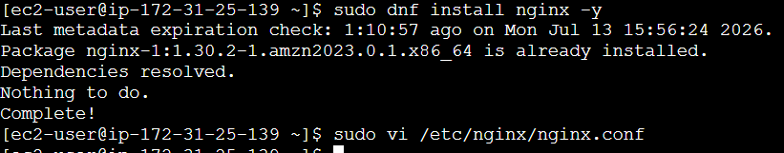
Find
listen 80;
Replace
listen 81;
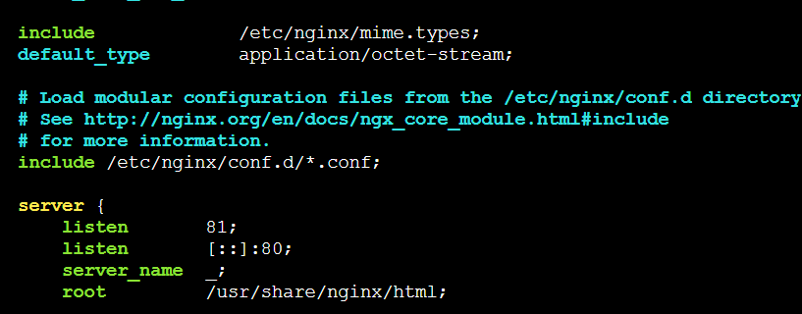
Create Sample Page
echo "<h1>Nginx Running on Port 81</h1>" | sudo tee /usr/share/nginx/html/index.html
Start
sudo systemctl enable nginx

sudo systemctl restart nginx
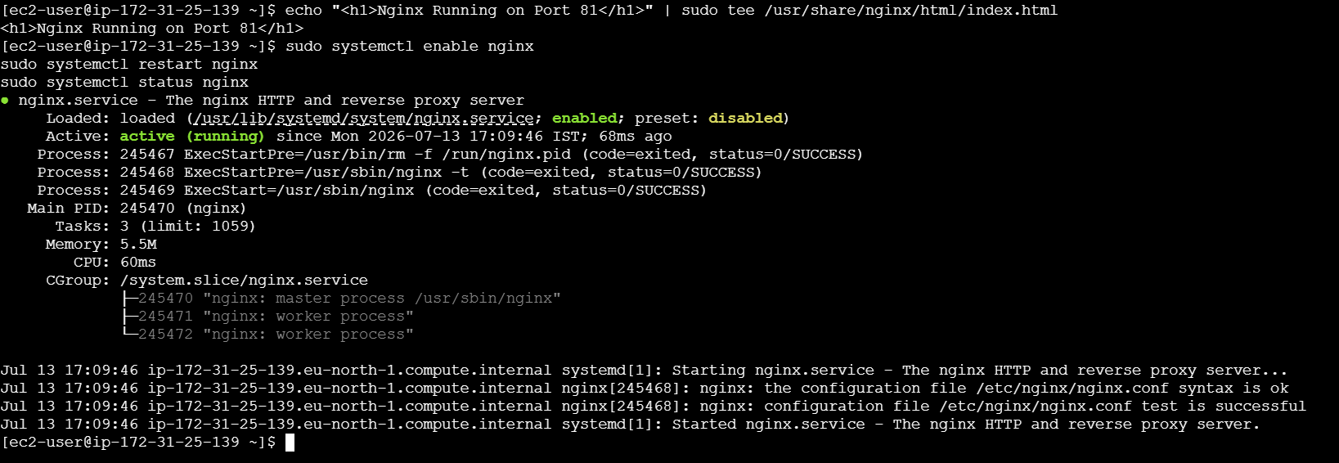
Verify
curl localhost:81
http://13.51.156.144:81/
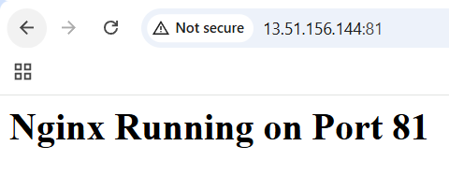

Step 8: Install and Configure Apache Tomcat
Verify Tomcat Installation
ls -l /opt/tomcat
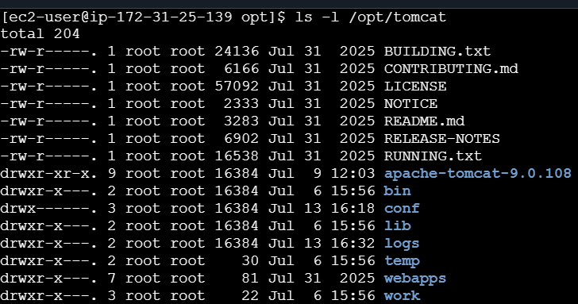
Change Tomcat Port to 8082
Edit the configuration:
sudo vi /opt/tomcat/conf/server.xml
Find:
<Connector port="8080" protocol="HTTP/1.1"
Change it to:
<Connector port="8082" protocol="HTTP/1.1"
Save and exit:
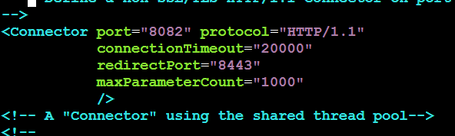
Start Tomcat
sudo /opt/tomcat/bin/startup.sh
Expected output:
Using CATALINA_BASE: /opt/tomcat
Using CATALINA_HOME: /opt/tomcat
...
Tomcat started.
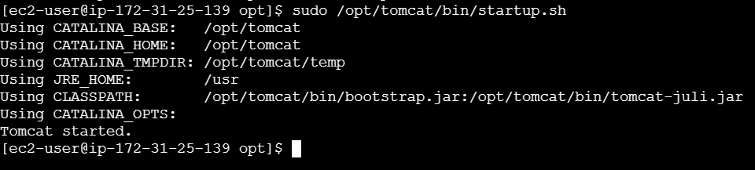
Verify Tomcat is Running
sudo ss -tulpn | grep 8082
Expected:
tcp LISTEN 0 100 *:8082 *:* users:(("java",pid=...,fd=...))
Your output already confirms this:
tcp LISTEN 0 100 *:8082 *:* users:(("java",pid=243195,fd=45))
✅ Tomcat is running correctly on port 8082.
Create Service :sudo vi /etc/systemd/system/tomcat.service
Paste
[Unit]
Description=Apache Tomcat
After=network.target
[Service]
Type=forking
User=ec2-user
Group=ec2-user

Environment=JAVA_HOME=/usr/lib/jvm/java-21-amazon-corretto

Environment=CATALINA_PID=/opt/tomcat/temp/tomcat.pid

Environment=CATALINA_HOME=/opt/tomcat

Environment=CATALINA_BASE=/opt/tomcat

ExecStart=/opt/tomcat/bin/startup.sh

ExecStop=/opt/tomcat/bin/shutdown.sh

Restart=always

[Install]
WantedBy=multi-user.target
Reload
sudo systemctl daemon-reload
sudo systemctl enable tomcat
sudo systemctl start tomcat

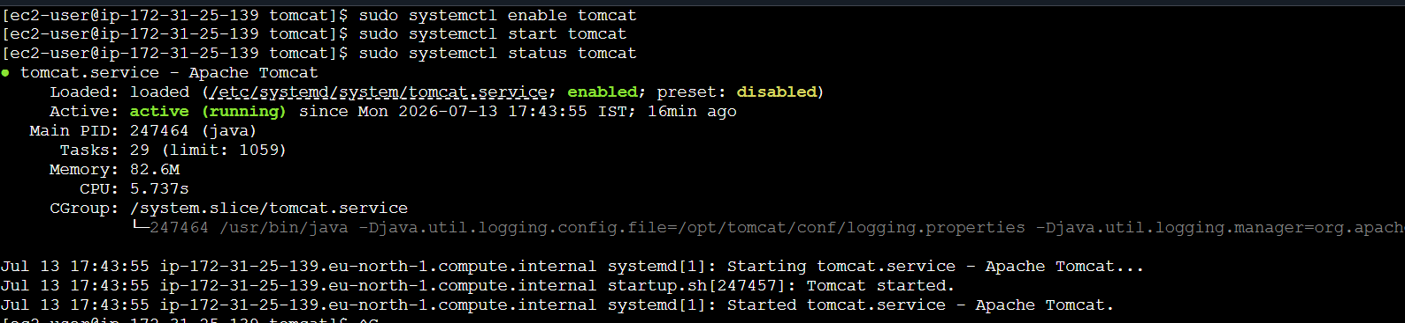

Access Tomcat
In your browser:
http://<EC2-PUBLIC-IP>:8082
You should see the Apache Tomcat welcome page.

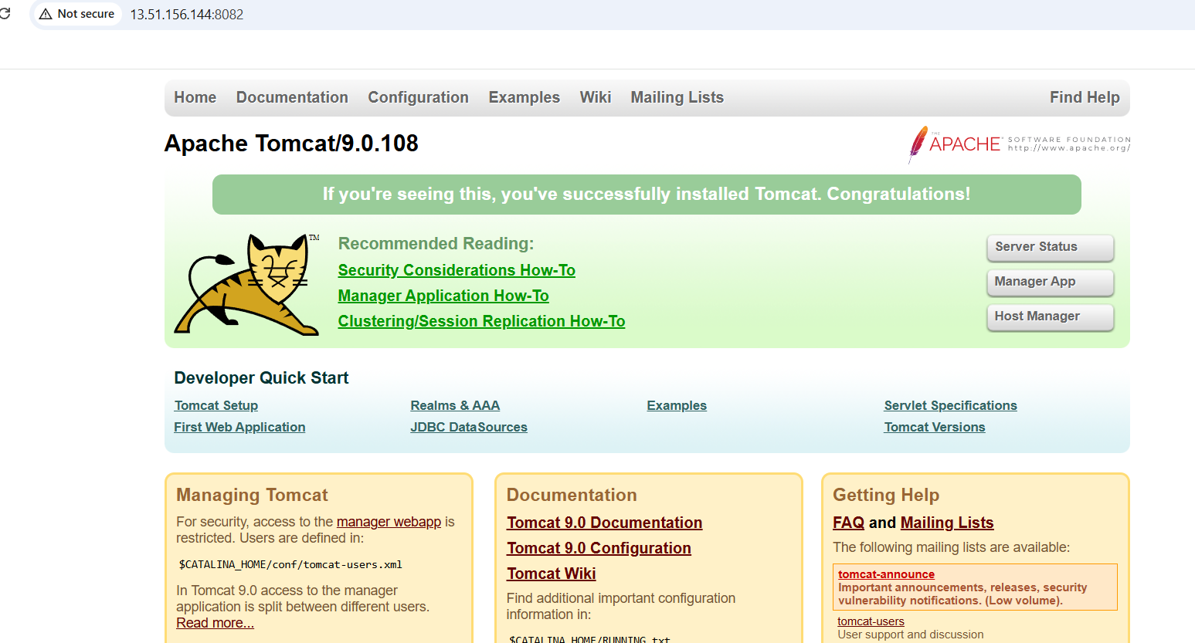

Step 9: Check Running Services
sudo systemctl status docker
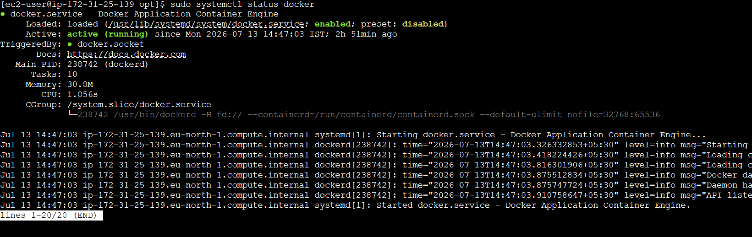
sudo systemctl status Jenkins
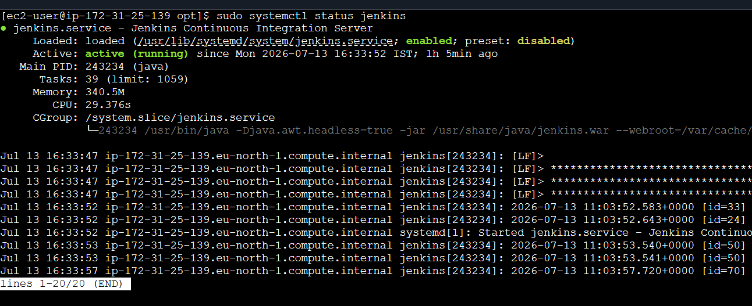
sudo systemctl status httpd
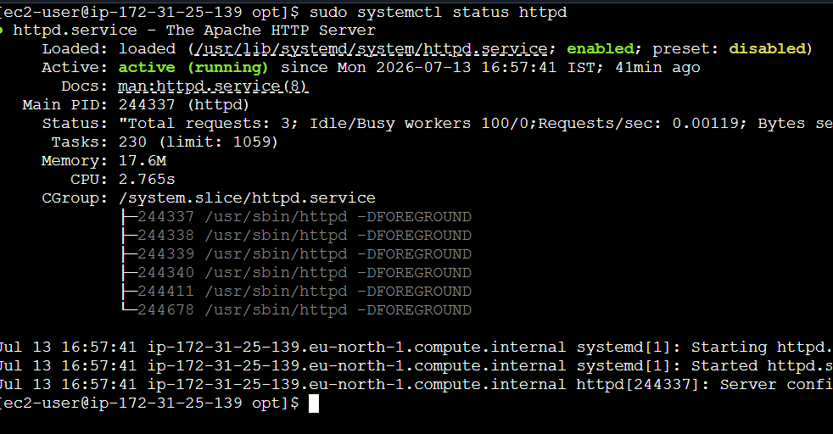
sudo systemctl status nginx
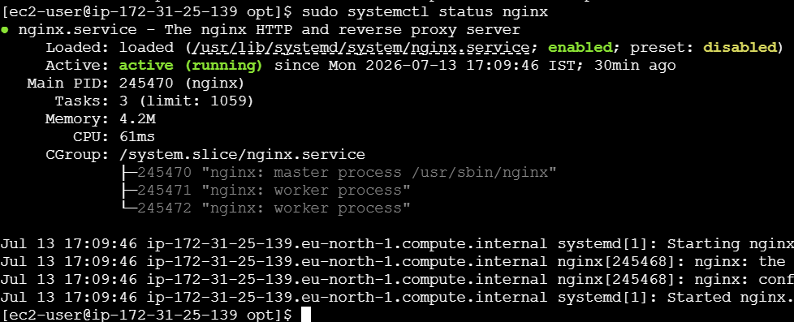
sudo systemctl status tomcat
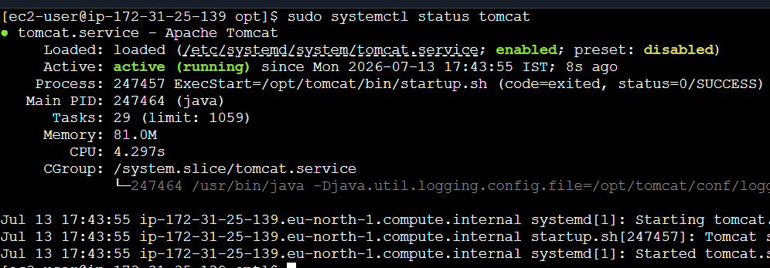
Step 10: Verify Listening Ports
sudo ss -tulpn
Expected
:8080 Jenkins
:82 Apache
:81 Nginx
:8082 Tomcat
